January | Frosty Winter
2022  School Spirit  Days | 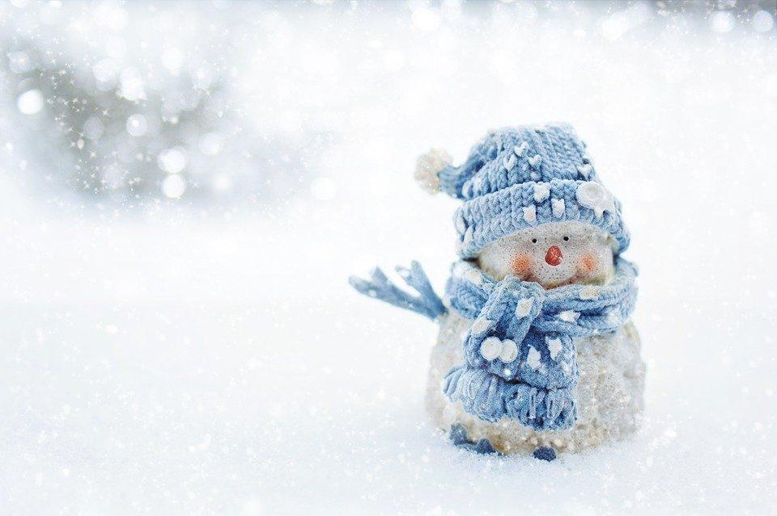

Sunday | Monday | Tuesday | Wednesday | Thursday | Friday | Saturday
 |  |  |  |  |  | 1
2 | 3 | 4 | 5 | 6 | 7 | 8
 | Winter Break | Staff Development (No school) | Return to School |  | Student of the Month Party
9 | 10 | 11 | 12 | 13 | 14 | 15
 |  |  |  |  | Staff Development (No school)
16 | 17 | 18 | 19 | 20 | 21 | 22
 | MLK Day  No School | No school for students, staff or support professionals | Peace Week “Powered by Kindness”  Dress as your fav Superhero | Peace Week  “Peace, Love & Kindness”  Wear Tie Dye | Peace Week  “It’s Your Job to be Kind”  Dress in your finest clothes
23 | 24 | 25 | 26 | 27 | 28 | 29
30 | 31

