OCTOBER | HAPPY HALLOWEEN
2021  School Spirit  Days | 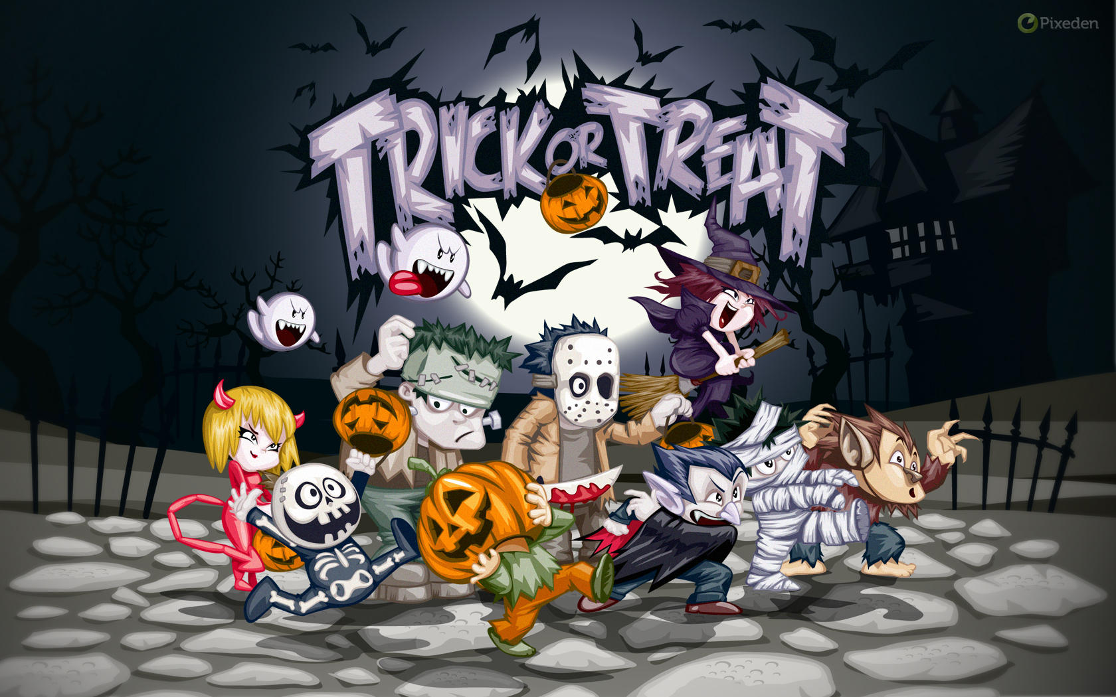
Sunday | Monday | Tuesday | Wednesday | Thursday | Friday | Saturday
 |  |  |  |  | 1 | 2
3 | 4 | 5 | 6 | 7 | 8 | 9
 | No School  Staff Development Day | Jersey Day  Wear your favorite sports team jersey | Mismatch Day  Dress in mix-matched clothing | Match Your Class Day  Pick a color or theme everyone in your class will wear | School Spirit Day  Show your school spirit by wearing Bailey colors (Burgundy, gray or white)
10 | 11 | 12 | 13 | 14 | 15 | 16
 |  |  | No School  Parent/Teacher  Conferences |  | Pink Day  Wear Pink to Support Girls & Women
17 | 18 | 19 | 20 | 21 | 22 | 23
Favorite Color
Day
Wear your favorite color from head to toe
24 | 25 | 26 | 27 | 28 | 29 | 30
 | Purple/Yellow or Green Day  Wear these Halloween colors or any combination of them | Halloween Shirt Day  Wear your favorite Halloween Shirt | Orange/Black Day  Wear these Halloween colors or any combination of them | Halloween Costume Day  Wear your Halloween Costume but no masks or weapons | No School  Nevada Day
31

